Compiling BMElib using : Intel Visual Fortran 11.1 (with Microsoft Visual C++ 2008 SP1 linker)

1. Set the BMElib Directory as current folder and then set “mvnlib” folder to MATLAB working DIRECTORY 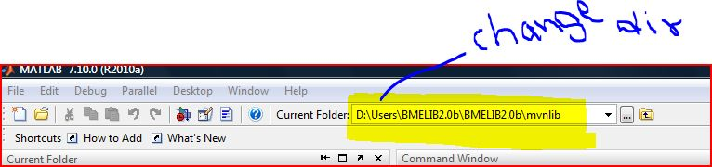

1. Set compiler ( make compiler ready to use it) 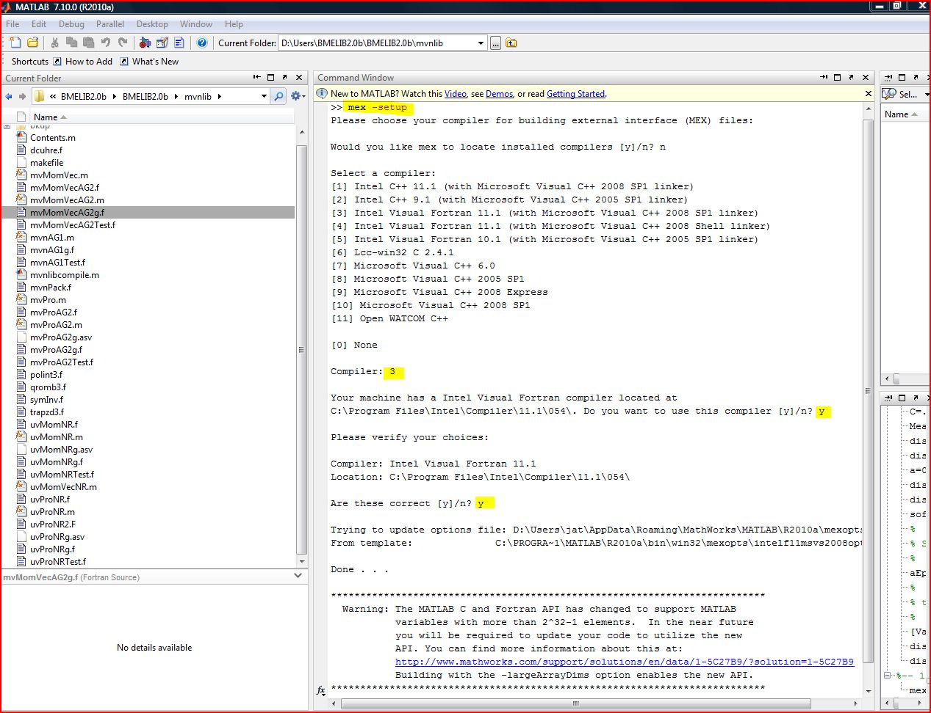
2. Compile “mvnlibcompile” function

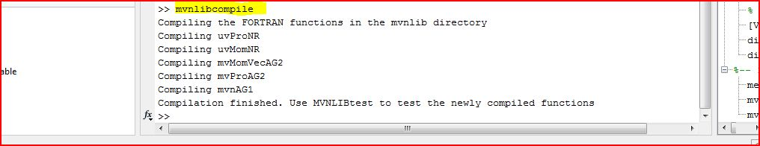

1. Test all functions in “mvnlib” to make sure Fortran Compiler generated “\*.mex32” files successfully 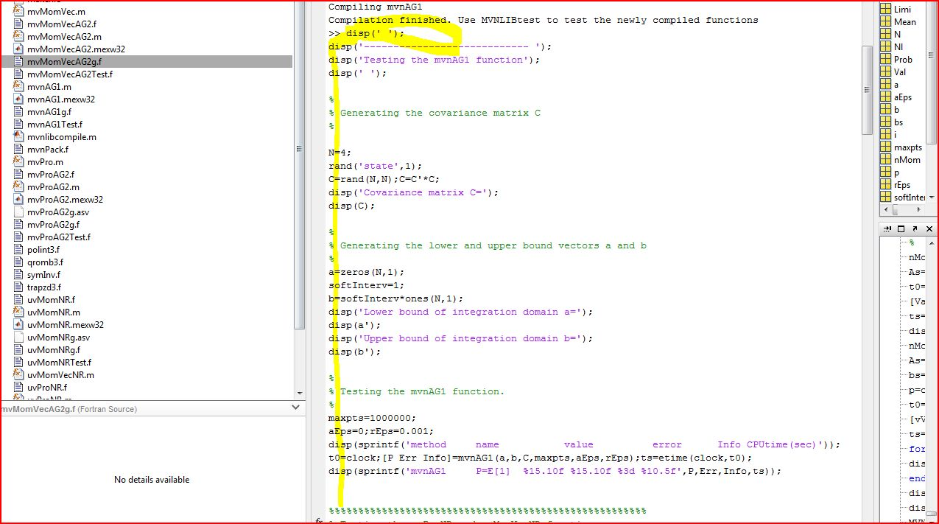 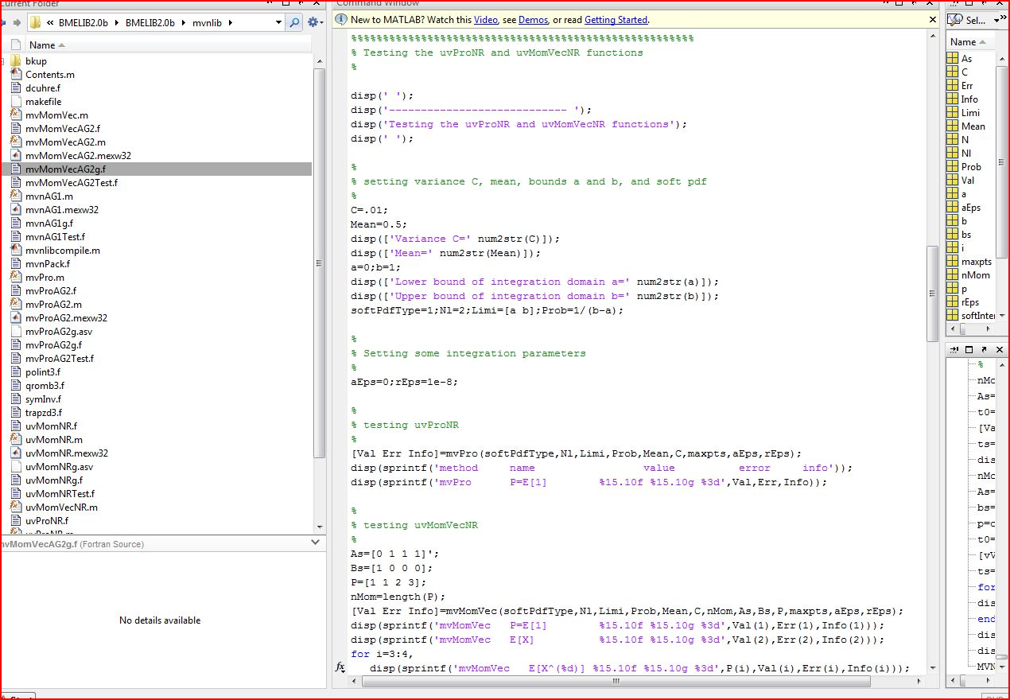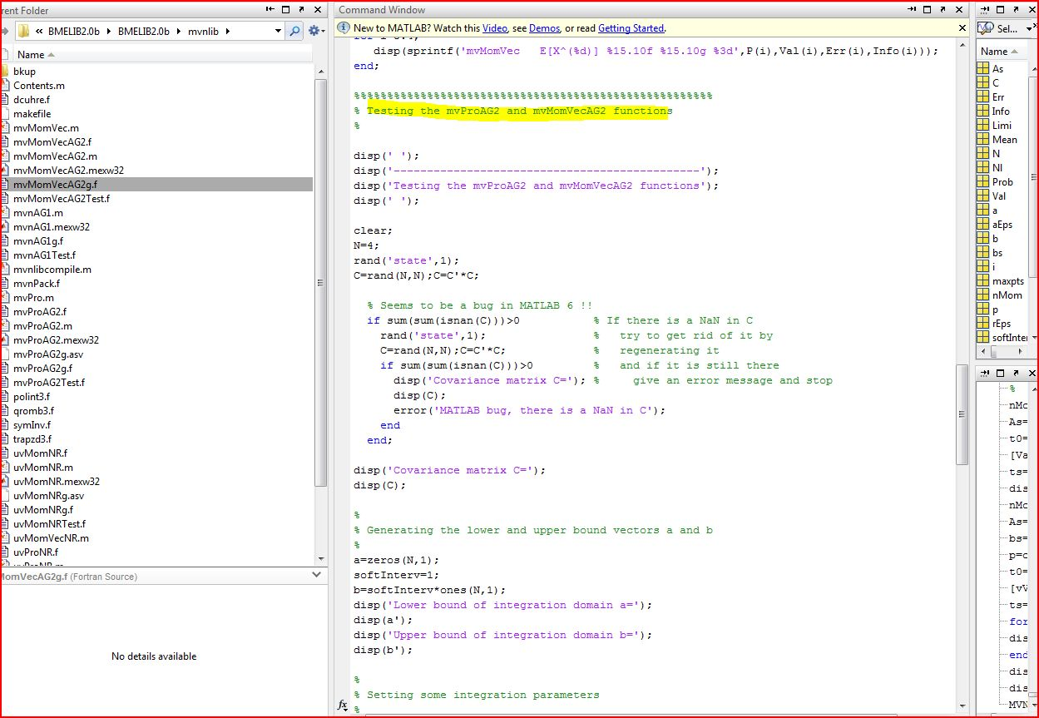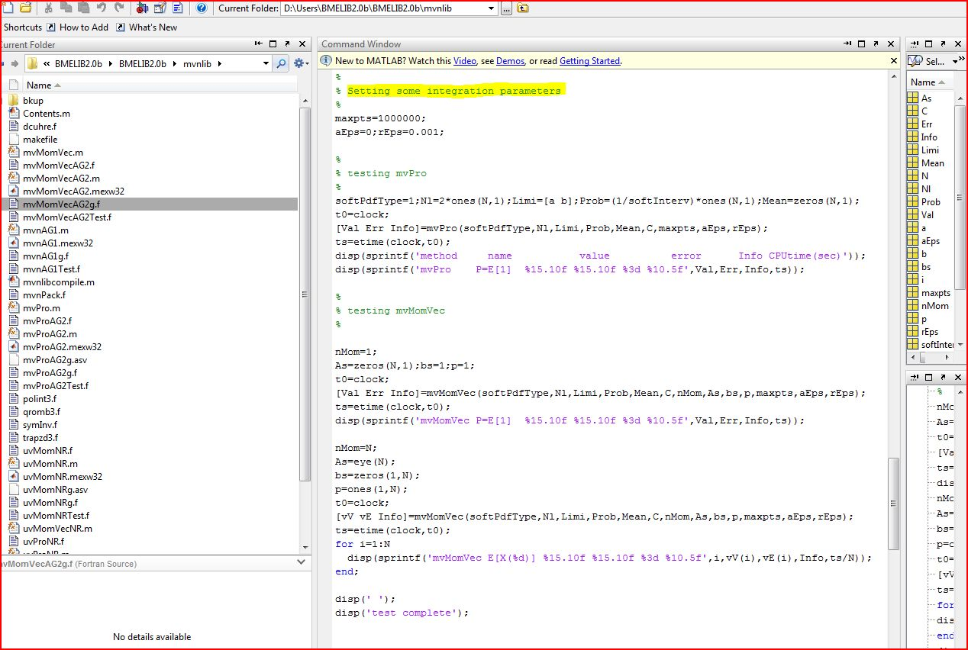
2. Check RESULTS after executing “MVNLIBtest” (\*.mex32” files) in MATLAB 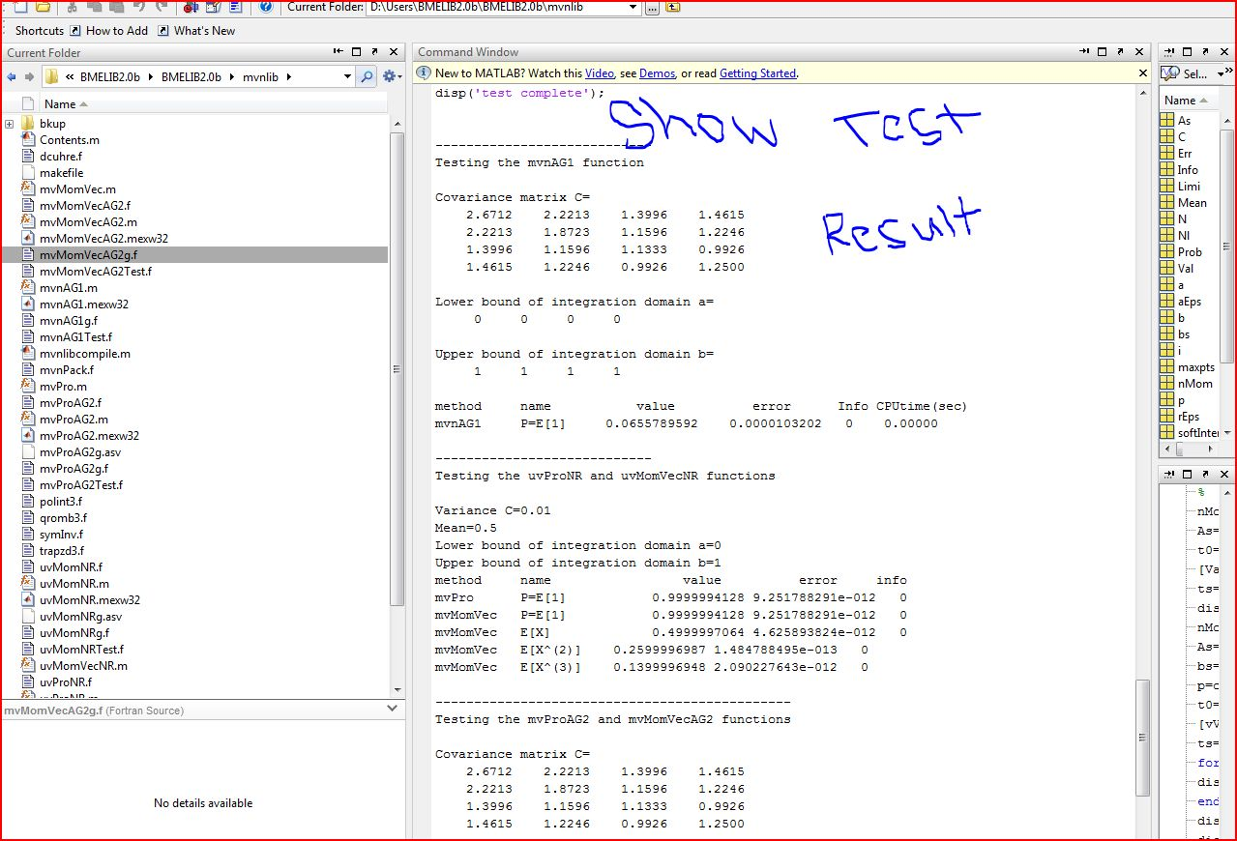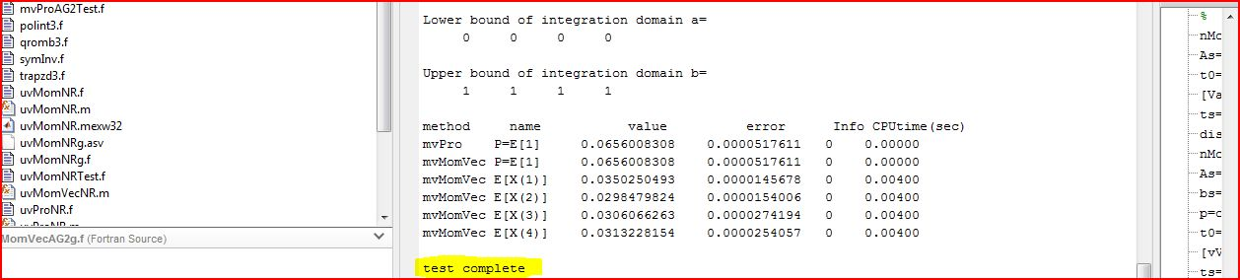

BINGO!!!!!!!!!!!!!!!!!!!!!!!!!!!!!!!!!!!!!!!!!!!!!!!